Laboratory 03

Jeffrey Daniel Leiva Cascante
Tamara Nicole Rodríguez Luna
Computer engineering department, Tecnológico de Costa Rica
IC4301 – Databases I
Teacher: Msc. Adriana Álvarez Figueroa.
September 20th 2022.

In this document are the evidence of laboratory 03 where you can see the objects created, data inserted, modified, among others.
Evidence:
- Check the total number of people that exist.
- In these images you can see the table Person full:
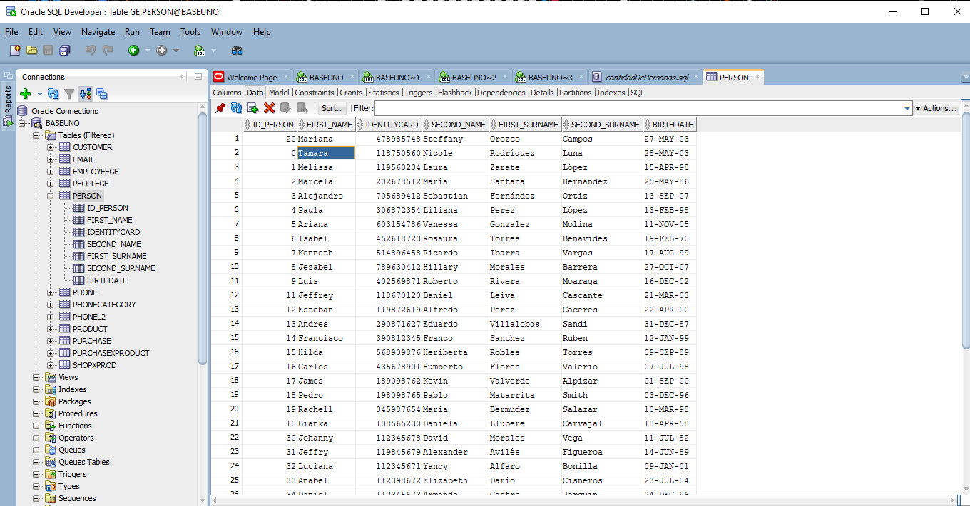
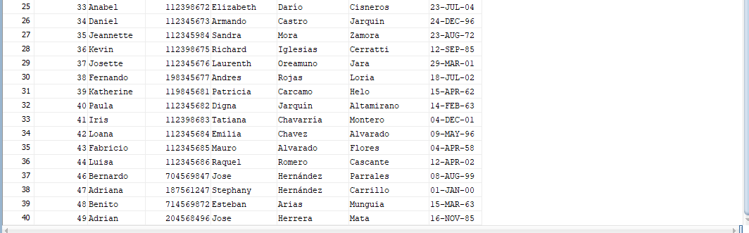
- This is the result of the query:
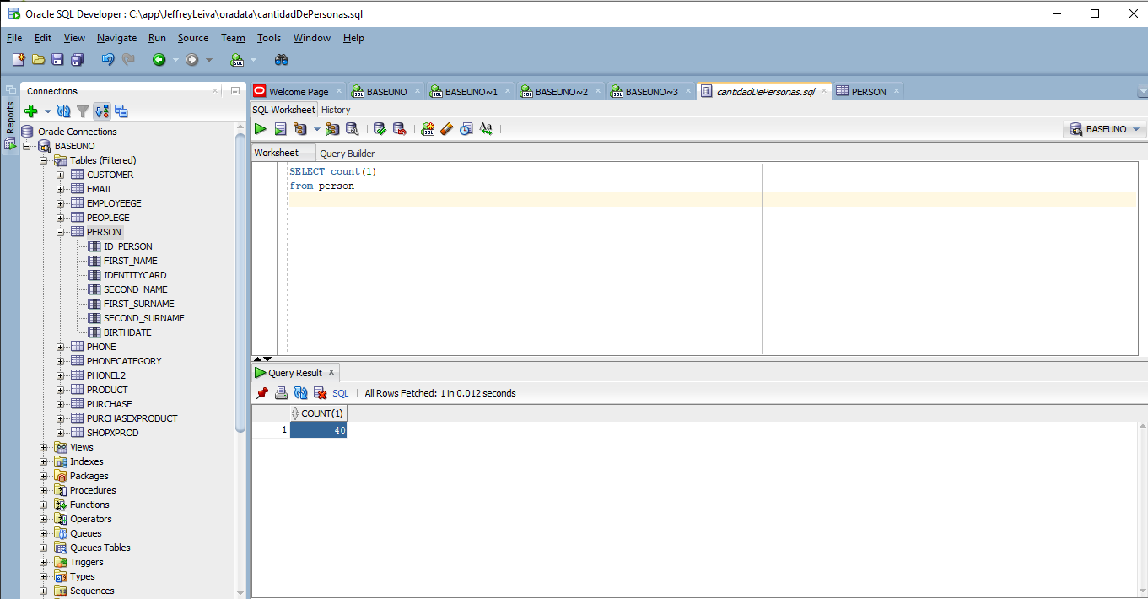
- Make a sql to get all the people whose name begins with the letter B.
- In these images you can see the table Person full:
- This is the result of the query:
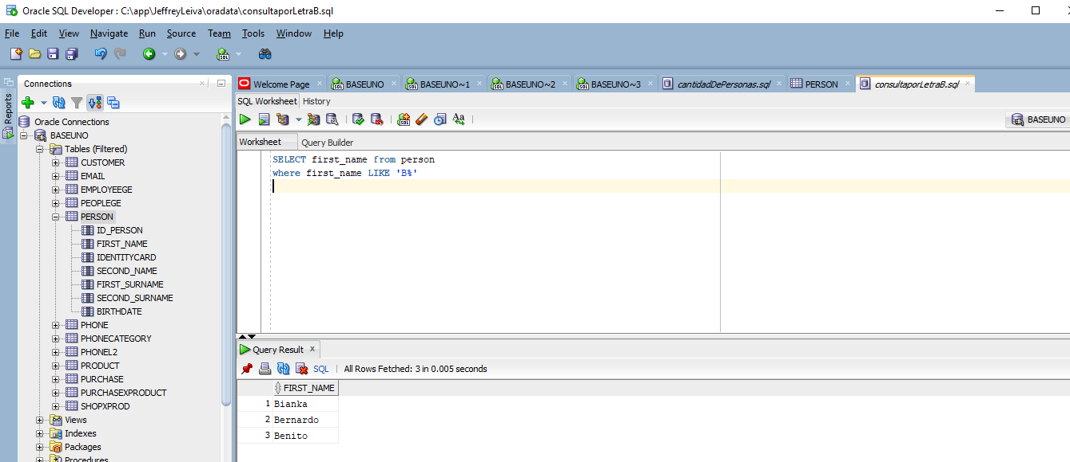
- Make a sql to get all the people whose name begins with the letter b (in
lowercase)

- This is the result of the query since there are no names with the letter b in lowercase does not show anything, because any name in our table starts with b and by standard in our database place all the names with their initial in capital letter:
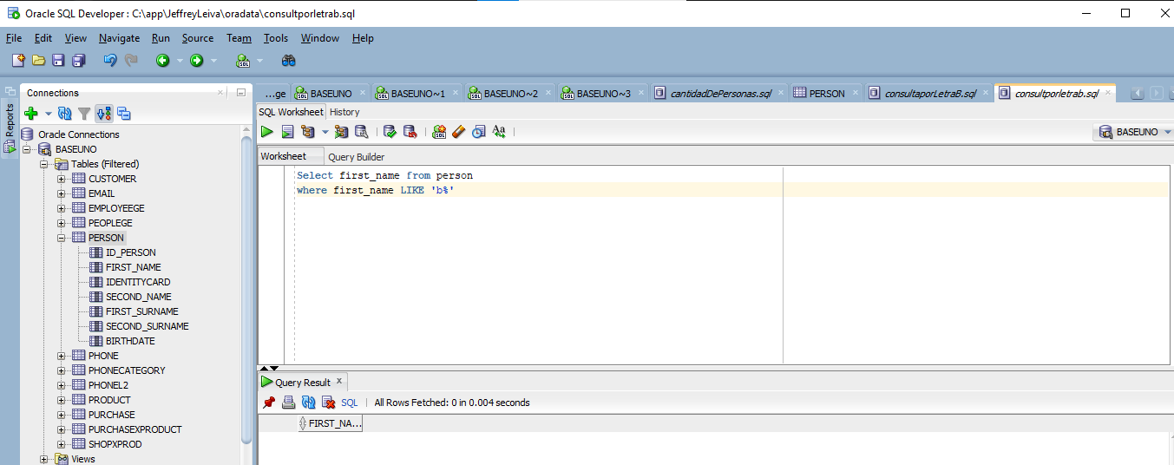
- Indicate the total number of phone numbers per person.
- This is an image of the table phone before the query:
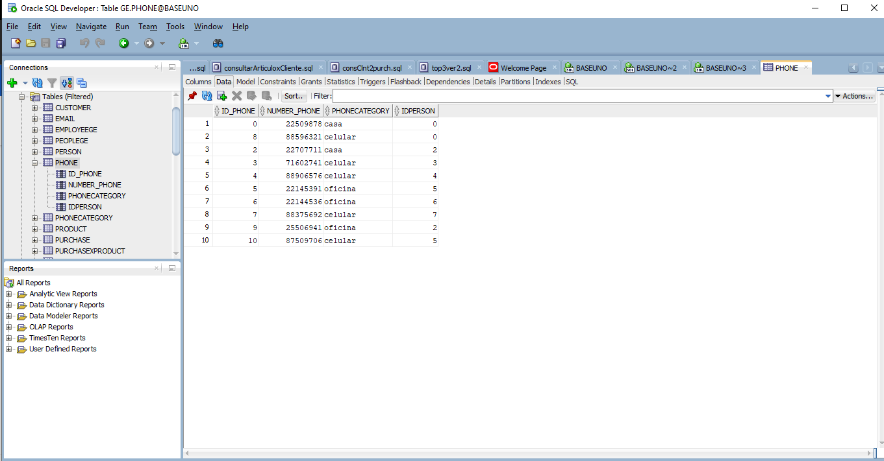

- This is an image of the result of query:
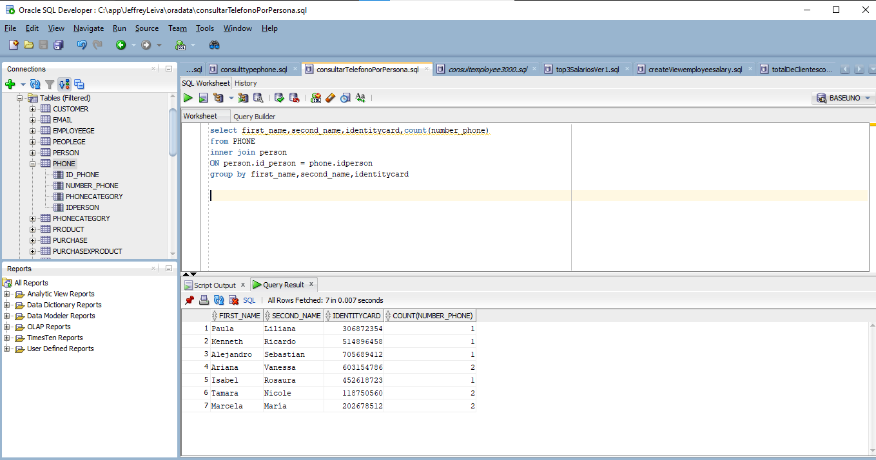

- Make a sql that returns all the people that have ‘casa’ as their type of phone:
- This is an image of the table phone after the query:

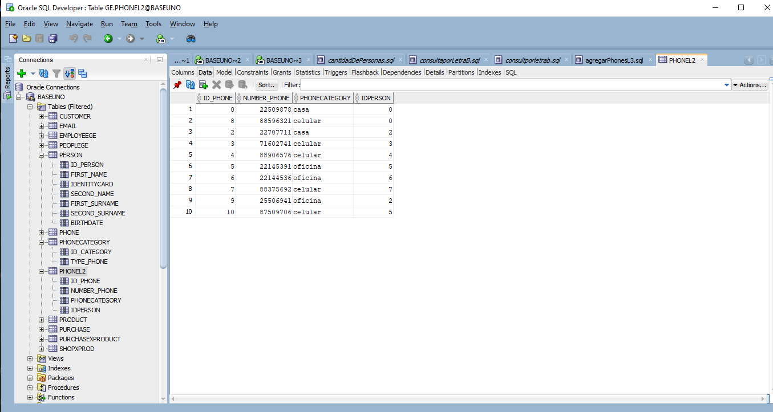
- This is the result of the query:

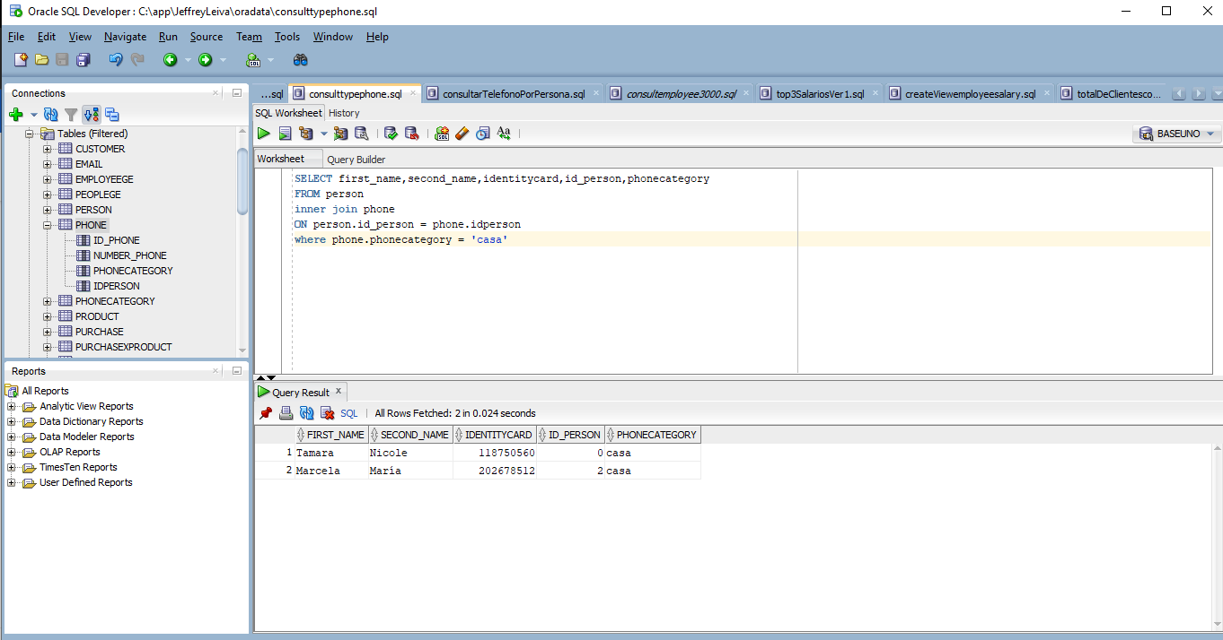

- Create a view that contains all the people that make less than $3000:
- These are an image of the table person:

- This is an image before the creation of the view:
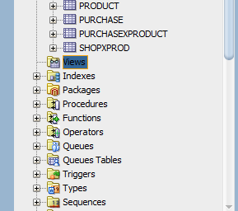
- This is an image after the query:
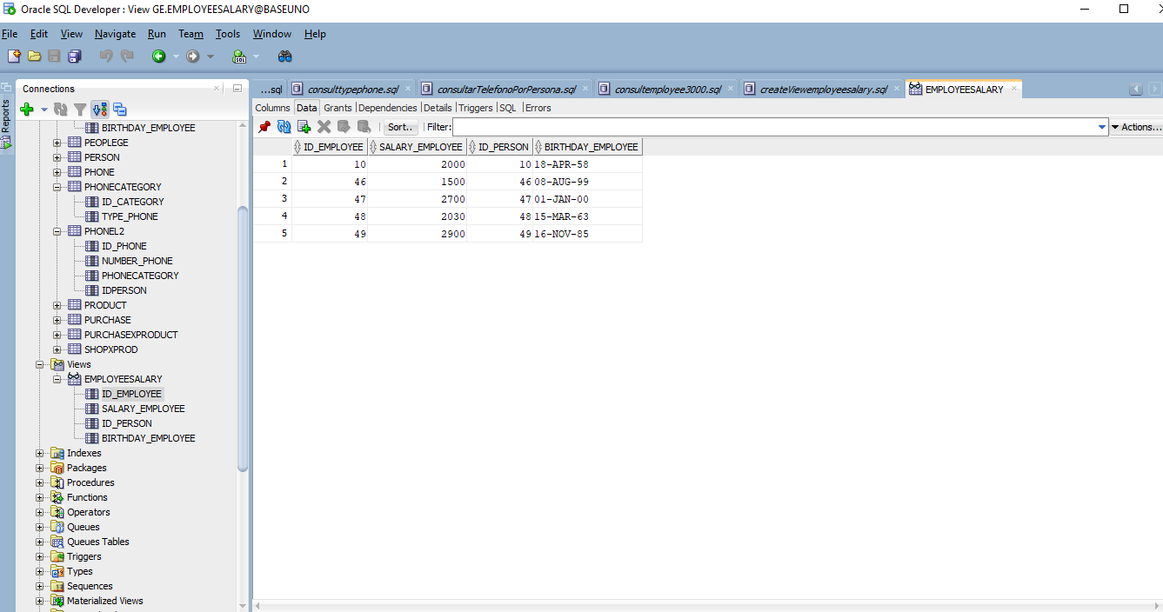

- Create two views with the top 3 of people with the highest salaries based on the next two queries. What is the difference between them?
select rownum id,first_name||' '||last_name nombre ,salary from (select first_name,last_name,salary
from employee order by salary desc) where rownum <=1;
------------------------------------------------------------
SELECT first_name||' '||last_name nombre,salary FROM (SELECT first_name,last_name,salary, RANK() OVER (ORDER BY salary DESC) salary_rank FROM employee ) WHERE salary_rank <= 1;
- Before the creation of the views:
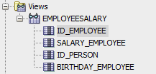

- After the creation of the view 1:

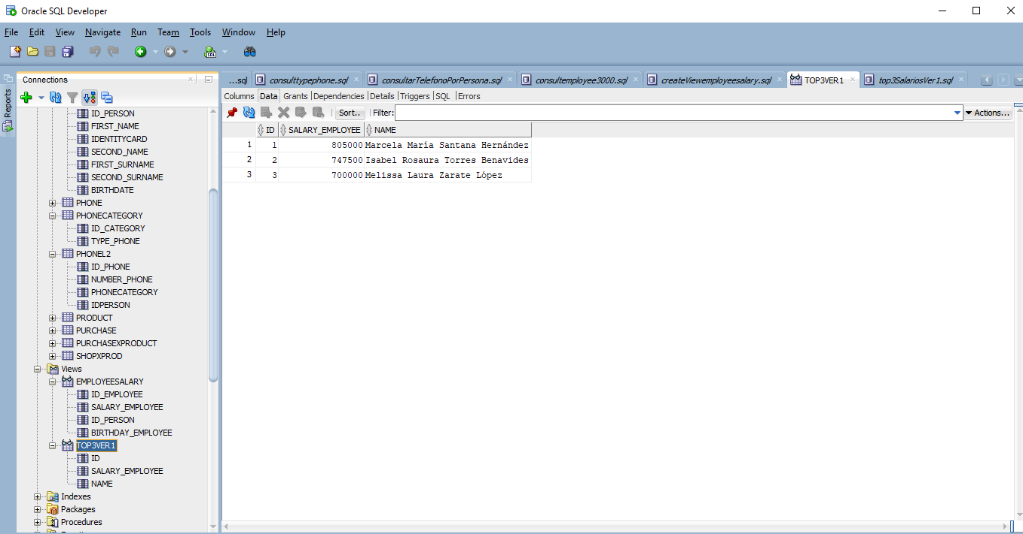

- After the creation of the view 2:
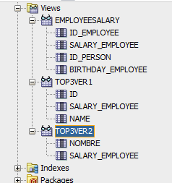
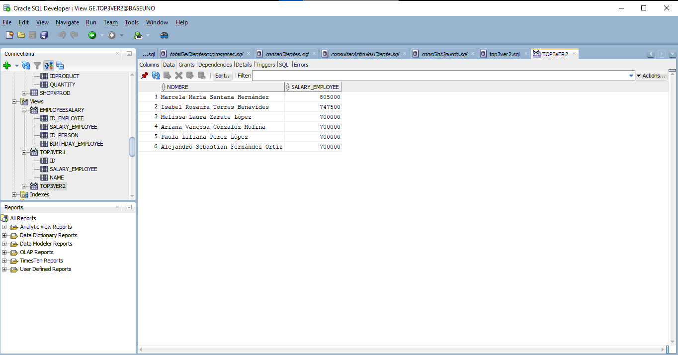

8. Consult the total amount of clients that have purchases
- Here you can see the table of purchases with the id of the customer that made them and the id of the purchase.

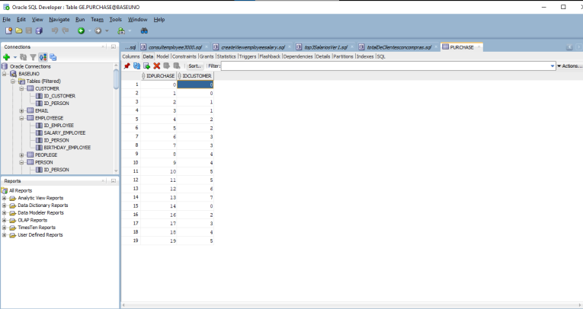
- Here is the result after the query:
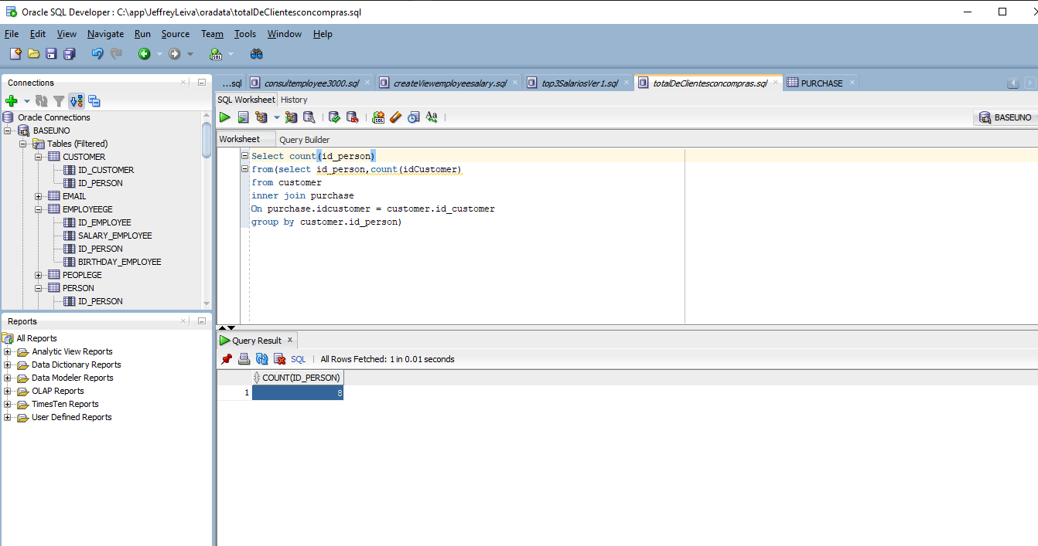

9. Consult the total amount of clients that exist
- Here is the result of the query:
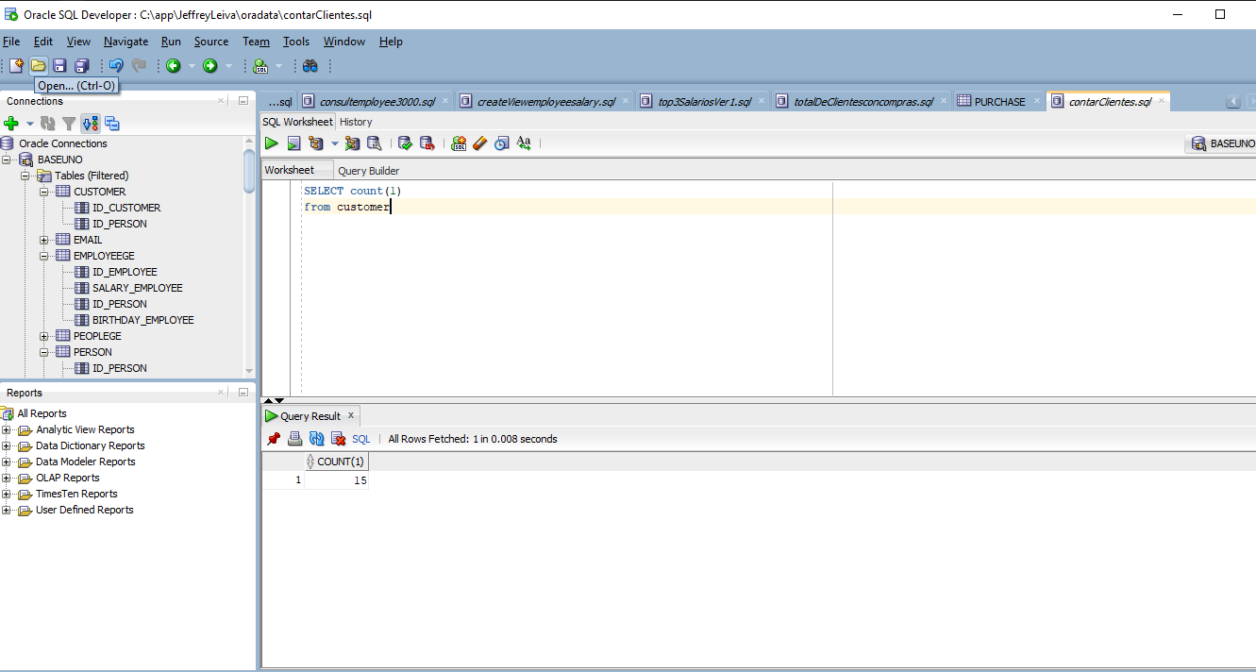

10. List the products bought by a client grouped by client
- Here you can see the result after the query:
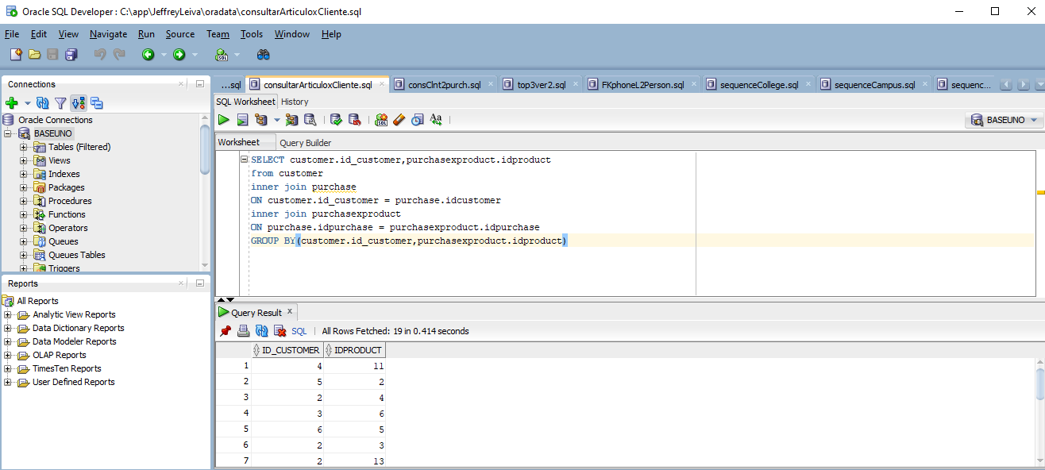

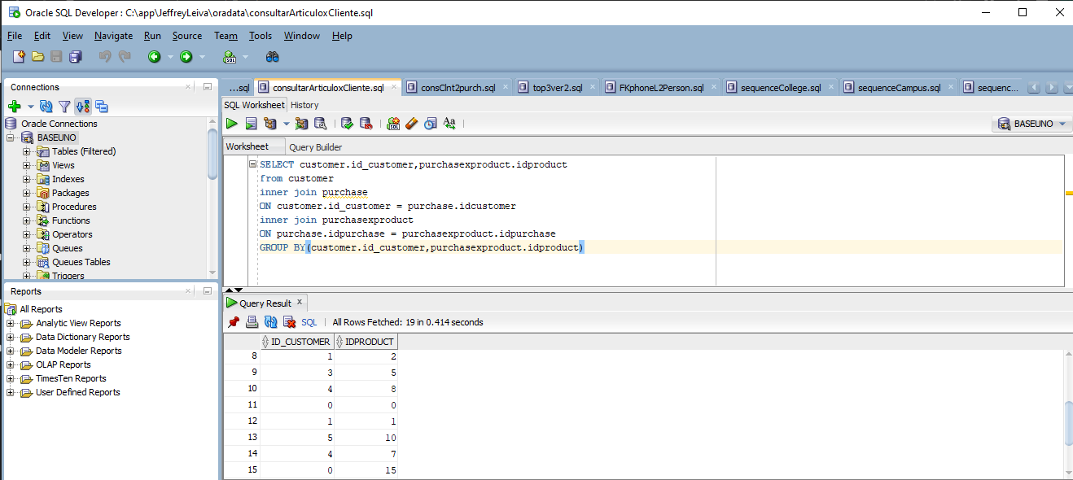
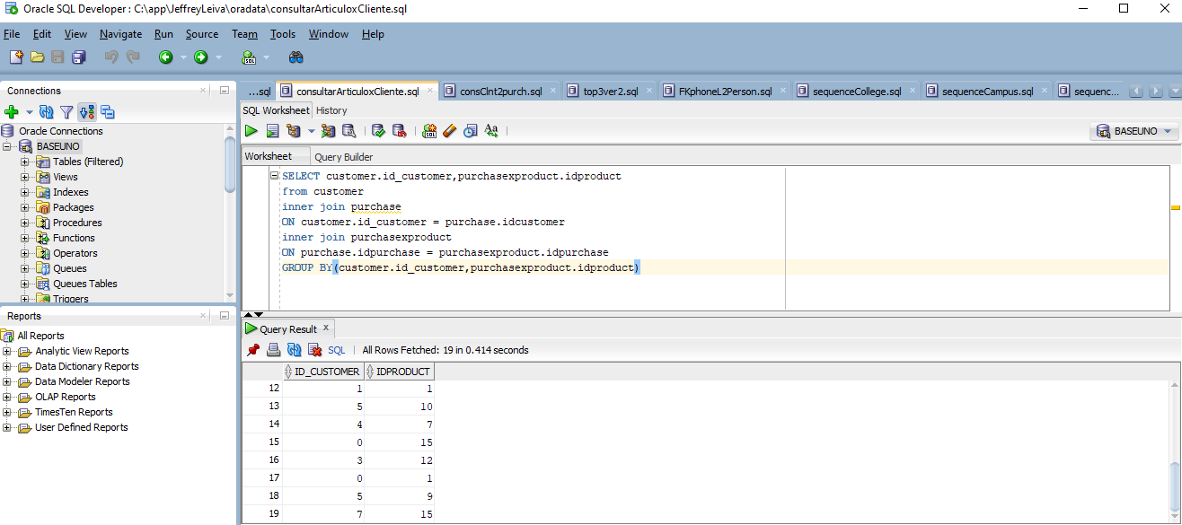
11. Make a sql of the clients that have more than two purchases.
- Here you can see the table of purchases, the customers 2,4,5,3 and 0 have 3 or more purchases.
- Here is the result of the query:
